**Calibrations assigned to each scan**

The program now remembers the calibration associated with every file series. If you have one of the images belonging to the series open, and click the button that saves the calibration, the default filename for the calibration will be the root file name of the current series, and the location of the cal file will be the image directory. When you open an image for which calibration has been associated, that calibration will be automatically loaded.

**Indexing peaks in ATREX**

Previously, in GSE_ADA peak indexing and determination of orientation matrix was done in RSV. Now this task can be performed in ATREX. To index a peak table open the Simulation window (Click on the “Simulate” button in “Predict” tab) and click on “Index button”. Indexing can only be performed if there are some peaks in the peak table.

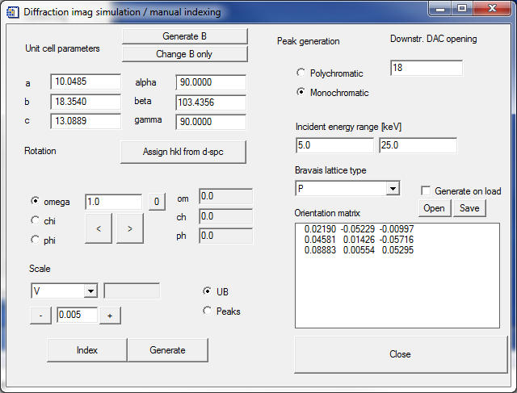

ATREX uses the external program, cell_now.exe for indexing. You will have to tell ATREX where to find that executable. It has to be located in a directory with write permissions. If this is the first time you are attempting to index on this computer, ATREX will open a window that will allow you to define the location of cell_now. After you select the proper location, ATREX will store the information and remember it next time it is needed.

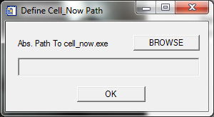

After executing cell now ATRES captures the results of indexing and displays the unit cell solutions it found in the Unit cell choices window. You have to select the solution you want to use. When you browse though the solution list, ATREX recognizes the most likely crystal system and transfers this information to the droplist, however, you can select a different crystal system if there is a reason (e.g. pseudosymmetry).

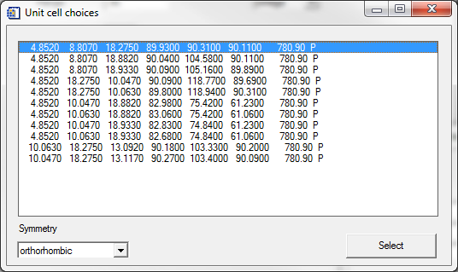

After you click on the “Select” button, the program will use the selected unit cell and refine orientation matrix, the result will be passed to the simulation window, and you can use it to calculate predicted peak positions. At the end of unit cell refinement peaks in the peak table that do not conform to the orientation matrix will be set to the selected state.

